**Simplified Menu**

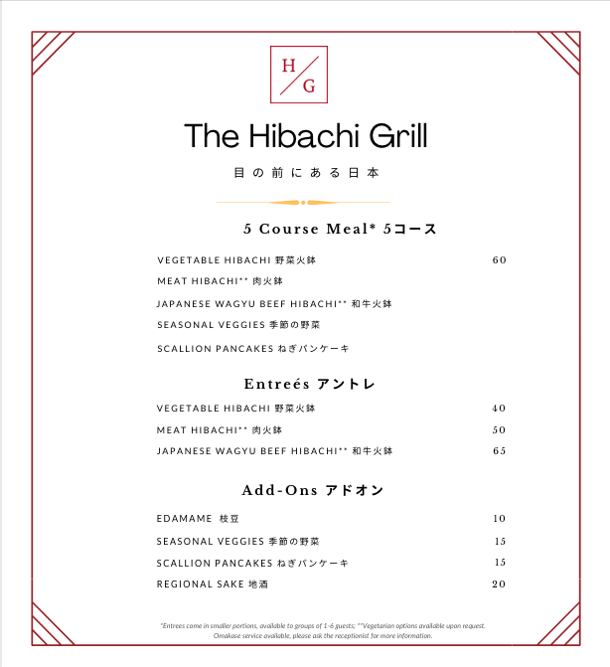

This is our revamped menu. Menu items such as sushi has been discontinued until further notice. The reasoning behind discontinuing sushi is simply because it is too much risk and not enough reward based on recent research on the following page.

We have also decided to raise menu prices instead of imposing a surcharge on the bill. The reasoning behind this is noted in the next page as well.

**Sushi - Discontinue.**

<https://www.seafoodsource.com/news/foodservice-retail/large-japanese-sushi-chains-see-sales-plummet-due-to-covid-19>

* Demand for sushi declined by 60-90% for the top 5 conveyor belt sushi chains in Japan.

<https://www.katom.com/learning-center/so-you-want-to-start-a-sushi-business.html>

* Sushi comes with more health risk than other food since most items are raw. Any health risks during a pandemic doesn’t makes sense.
* We also noted that sushi ingredients are expensive and spoils fast. Because of this, it is risky to invest in sushi without having an accurate picture of demand.
* If we are marketed to be a premium brand, we cannot tolerate sushi that is not fresh. If we are premium and cannot serve fresh, premium sushi, then we might as well discontinue it.

[Coronavirus Fears in China Find a New Target: Salmon](https://www.nytimes.com/2020/06/18/world/asia/coronavirus-china-salmon.html)

[LIVE UPDATES: More factory closures as experts question China's seafood motives](https://www.intrafish.com/coronavirus/live-updates-more-factory-closures-as-experts-question-chinas-seafood-motives/2-1-746616)

* There was a report in China that states how imported salmon can contain traces of coronavirus.
* This applies to all seafood
* Whether it is true or not, the rumors can have an impact on sushi demands.
* It is best to cook food thoroughly to avoid this rumor. Raw fish doesn’t fit in this category.

**Surcharge vs Raised Menu Price**

<https://www.wlwt.com/article/customers-are-finding-coronavirus-surcharges-at-restaurants/32468216>

* Kiko Japanese Restaurant implemented a COVID surcharge on the bill instead of raising menu prices.
* This was met with opposition and criticism from customers.
* They eventually remove the surcharge in favor of increase in menu prices.
* This happens to Kiki Japanese Restaurant and Bootleggers BBQ.